The 2016 Harlaxton Medieval Symposium
The Great Household, 1000-1500
Tuesday 19th – Friday 22nd July, 2016

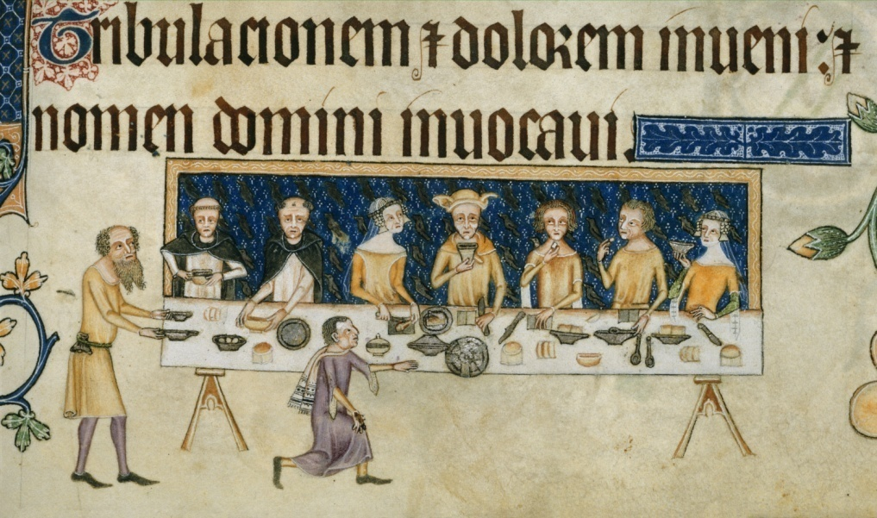
© the British Library Board, Add. MS 42130, f. 208

The theme of the 2016 Symposium is the medieval great household, from the eleventh to the early sixteenth century, with a focus on elite contexts in the British Isles. Papers will look at changing structures within the household; household membership, lords and their servants; domestic material culture; literature, music and entertainment in the household; the role of the household chapel; sensory environments, consumption and the routines of the household. Delegates will be given a guided tour of Harlaxton Manor (our own ‘Great Household’) and our afternoon outing will be to Gainsborough Old Hall, one of the finest and best-preserved fifteenth-century manor houses in England. The conference banquet will feature food inspired by authentic cuisine from the medieval great household. Our keynote will be delivered by Chris Dyer (University of Leicester).

Further information, including a provisional programme, will be available Easter 2016.

David Harry
Symposium Secretary
E: harlaxtonsymposium@gmail.com

